**Universidad Mariano Gálvez de Guatemala**

**Boca del Monte**

Ingeniería en Sistemas. Ciclo II, “c”

Jornada Sábado.

**ALGEBRA LÍNEAL**

HENRRY WALDEMAR SONTAY CHAN



**Nombre:** Luis Fernando Lima Ixcuná

**Carné:** 7690-20-17409

1. **x - y = 3**

x = 3 + y

x = y + 3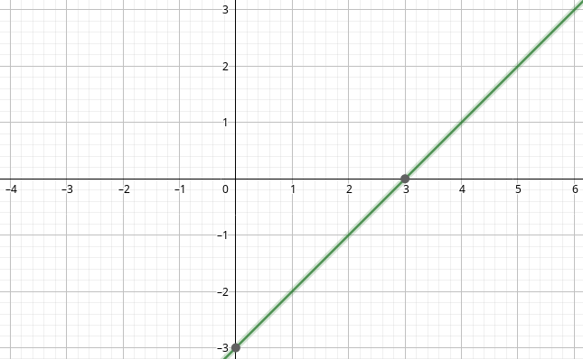

1. **4x + 5y = 0**

4x = -5y

x = -5/4y

x = 1.25y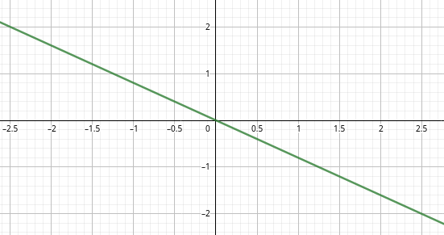

1. **7x + 3y = 0**

3y - 7x

y = 7/3

y = -2.33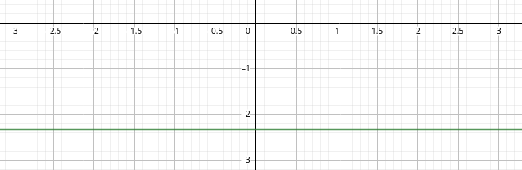

1. **7x + 4y = 1**

4y = 1 -7x

y = 1/4 - 7/4x

y = -7/4x +¼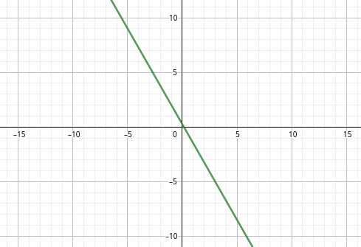

1. **-13x + 3y = 7**

-13x = 7 -3y

x = -7/13 + 3/13y

x = 3/13y -7/13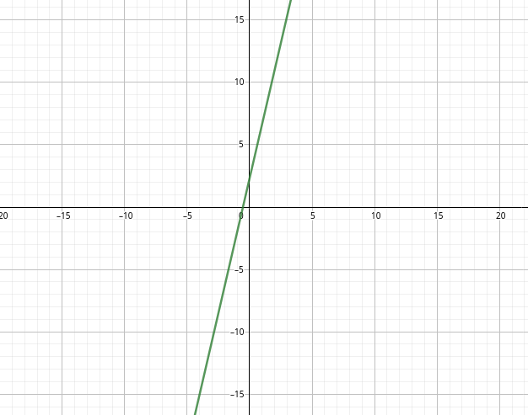

1. **-2x + 3y = 3**

3y = 3 +2x

y = 1 + 2/3x

y = 2/3 x +1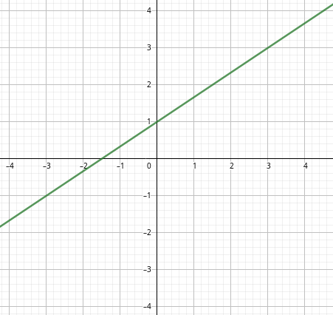

1. **-2x + 4y = 8**

-2x = 8 - 4y

x = -4 + 2y

x = 2y - 4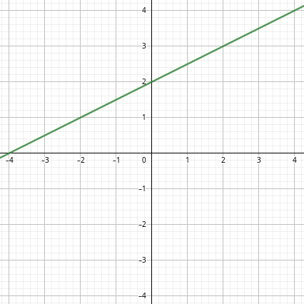

1. **-5x + 7y = 3**

-5x = 3 - 7y

x = -3/5 + 7/5y

x = 7/5y - 3/5

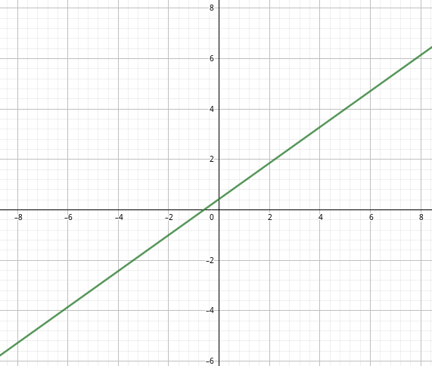

1. **ax + by = c**

ax =c -by

x = c-by/a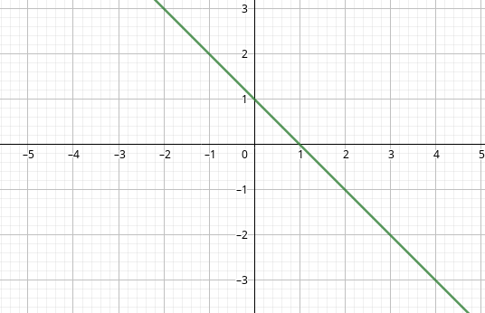

1. **2x + 3y = 3**

3y = 3 - 2x

y = 1 - 2/3x

y = -2/3 x + 1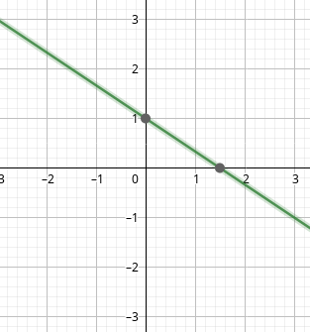

1. **4x - 3y = 0**

4x = 3y

x = 3/4 y

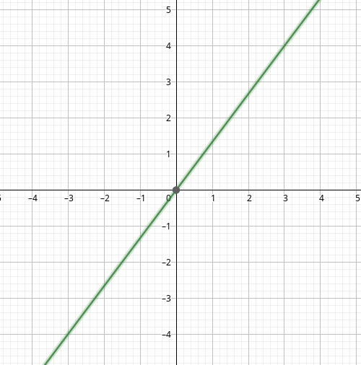

1. **3x - 7y = -5**

3x = -5 + 7y

x = -5/3 + 7/3

x = 7/3 y - 5/3

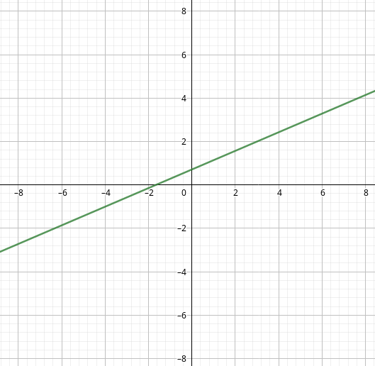

1. **7x + 4y = 0**

7x = -4y

x = - 4/7 y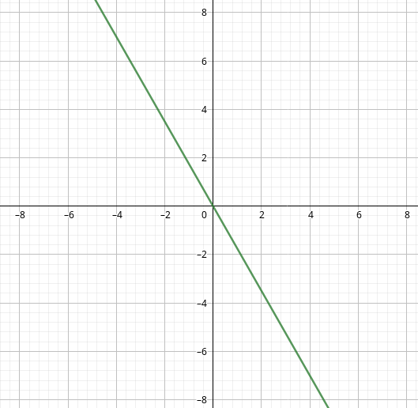

1. **9x - 3y = 3**

9x = 3 + 3y

x = 1/3 + 1/3 y

x = 1/3 y + 1/3 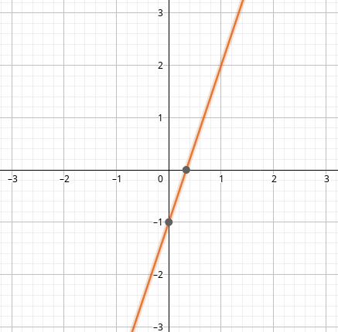

1. **x + 2y = 5**

x = 5 - 2y

x = -2 + 5y

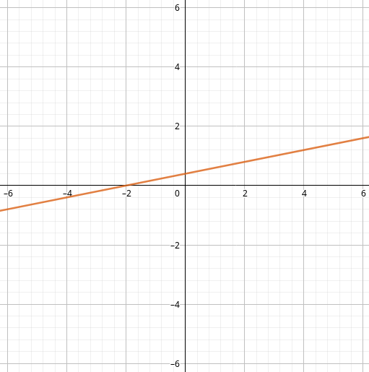

1. **-7x + 2y = -9**

2y = -9 + 7x

y = -9/2 + 7/2 x

y = 7/2 x - 9/2

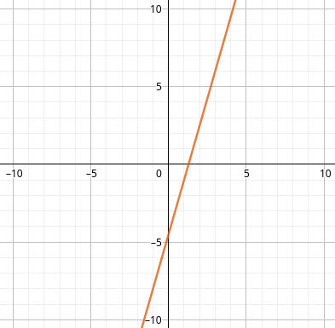

1. **ax + by = c**

ax =c -by

x = c-by/a



1. **bx + ay = d**

bx = d - by

x = d-ay/b